Project Proposal on

**Library Management system**



Computing Project

Level 5 Diploma in Computing

Softwarica College of IT & E-Commerce

Kathmandu, Nepal

Submitted by: Kapil Pandey Submitted to: Sudeep Lal Bajimaya

NCC Id: 00176098

Contents

Chapter 1 -Introduction 2

1.1 – Introduction of System 2

1.2 – Background of System 3

1.2.1 – Problem statement 3

1.3 – Justification of Project 3

1.4 – Overview of Purposed System 3

Chapter 2 –Scope 4

2.1 – Aim 4

2.2 – Objective of Project 4

2.3 – Features to Be Included 4

2.4 – Overview of the Scope 5

Chapter 3 –Development Methodology 5

3.1 – Methodology to be used 5

3.2 – Design Pattern 7

3.3 – System Architecture 8

Chapter 4 –Scheduling 9

4.1 – WBS (Work Breakdown Structure) 10

4.2 – Milestones 11

List of Milestone 12

Description of Milestone 12

4.3 – Gantt chart 14

Chapter 5 –Risk Management 16

Chapter 6 –Configuration Management 18

6.1 -Version Control 18

6.2 -Release Management 20

6.3 – Change Management 20

Chapter 7 –Conclusion 21

Chapter 8 -References 21

Table of Figures

Figure 1 Waterfall Model 6

Figure 2 Model View Controller. 8

Figure 3 3-tier architecture model. 10

Figure 4 WBS diagram. 11

Figure 5 scheduling of the project. 15

Figure 6 Gantt chart of Library Management System 16

Figure 7 GitHub directory of Library Management System 19

Figure 8 Project Local backup Directory. 21

Table of Table

Table 1: Time Estimation of the Project. 12

Table 2: likelihood. 17

Table 3: Consequence. 18

Table 4: Risk Management. 18

# Chapter 1 -Introduction

## 1.1 – Introduction of System

The project library Management System is library management software for monitoring and controlling the transaction in a library. The project “library management system” is develop in PHP language, which will be mainly focuses on basic operations in a library like adding new member, new books, updating new information, searching books and members and facility to borrow and return books and MySQL database for recording the users and library data.

## 1.2 – Background of System

The main purpose for choosing library management system is to upgrade manual system into computerized system. In manual system people may find difficult to handle library operation like keep records regarding books and student borrowers etc. So, in manual system record keeping is not reliable there is high chance of data redundancy and data loss. On the other hand it needs lots of worker to manage library which may cost a lot. On borrower’s point of view, in manual system they can’t find the book exactly what they needed and sometimes they searched book that is not available in the library which may lose their time.

So, therefore to make library efficient, reliable I plan to upgrade manual system into computerized system and also to overcome the weakness of manual system.

### 1.2.1 – Problem statement

* Upgrading manual system into computerized system for recording library data.
* Reducing cost for managing library.
* Have proper record of database of a user and less chance of having data redundancy
* Can have user friendly admin and user login interface.
* Have proper communication between Librarians and member.

## 1.3 – Justification of Project

A good library management system improves the effectiveness of the librarians and library users and also provide service to member. It also helps to permits librarians to easily list books and keep proper records of books issued, reissued and those not return and it will also help to check the availability of any books that library might need. A good library management system helps to save the time, it increase the productivity of library workers, it reduces the cost of managing a library and at last it improves the presentation of the library.

## 1.4 – Overview of Purposed System

Library management system is windows application written for windows operating system, planned to help users to preserve and unify library. This software is easy to use for both beginners and advanced users. It have features like, having an attractive user interface, joint with strong searching attachment and reporting capabilities. The library system helps to get a good idea of which are the books borrowed by the members and also checks which book are not available in library. The project is concerned with developing a library management system using object oriented programming language.

# Chapter 2 –Scope

## 2.1 – Aim

The following aim for this project are given below:

* The main objective of Library management System is to increase and upgrade the prevailing system by growing its productivity and efficiency.
* The software increases the working approaches by substituting the current manual system with the computer-based system.

## 2.2 – Objective of Project

The following objective for this project are given below:

* The objective of the library management system is to handle the whole action of a library.
* Improve a system that can substitute the manual library management system into computerized system.
* Improve a database which stores user information and book information with trustworthy search capability.
* Should have good-looking user interface to navigate through the system with having user friendly environment for user.
* Separate logins for both administrator (librarian) and users. So that admin can issue and return books, add/edit/search/delete books and user details whereas user can search the books and view their details.

## 2.3 – Features to Be Included

The following features that are available to librarian are:

* A librarian can issue a book to the member.
* Can view the list of books available in group.
* Can have access to all the account of the student.
* Edit the information of books.
* Add books and their information to the database.
* Can take the book returned from students.
* Can have librarian control panel which allow them to add, remove, edit the books.

The following features that are available to member are:

* Can view different group of books available in the library.
* Can view the list of books available in group.
* Can own an account in library.
* Can view books issued to him.
* Can search for particular book.

The following features that system needs:

* Easy and user friendly login interface.
* Proper monitoring by the administrator which includes updating account status, showing message if user attempt to issue more than one books.
* Assigning fine if member skip the date of return.

## 2.4 – Overview of the Scope

* The main reason for having library management system is to provide book information to member and employee of library.
* This system also provide information to member which books are available in library and which books members will able to issue for reading purpose.
* In this library management system anyone can become member to read books by filling a member form.

# Chapter 3 –Development Methodology

## 3.1 – Methodology to be used

In this project analyzing, designing, development and testing will be done by single person. So for this small project waterfall methodology is best to use. Due to unlikely change in requirement waterfall model is suitable for this project.

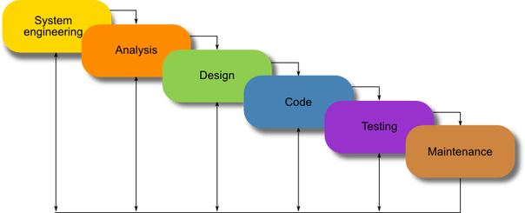

Figure 1 Waterfall Model

When waterfall model is used:

* Requirements are very well known, flawless and static.
* Product description is steady.
* Technology is understood.
* There are no vague requirements
* Sufficient funds with essential knowledge are available easily.
* The project is small.

Advantage of waterfall model are:

* This model permits for departmentalization and decision-making control.
* This model is simple and easy to understand and use.
* It is easy to manage due to the inflexibility of the model – where each stage has precise deliverables and a criticism process.
* In this model stages are handled and completed one at a time.
* This model is suitable for smaller projects where requirements are well understood.

Disadvantage of waterfall model are:

* In this model it does not permit for much reflection or revision.
* It is very difficult to go back and change something once an application is in testing stage and doesn’t meet the project requirements.
* No functional software is created until late throughout the life cycle.
* There is high chance or risk and uncertainty.
* This model is not good for large project and object oriented project.
* This model is not suitable for long and ongoing projects.
* This project is not suitable, where there is high chance of changing of the requirement.

## 3.2 – Design Pattern

In software engineering, a design pattern is a general repeatable solution to a commonly occurring problem in software design. A design pattern isn't a finished design that can be transformed directly into code. It is a description or template for how to solve a problem that can be used in many different situations.

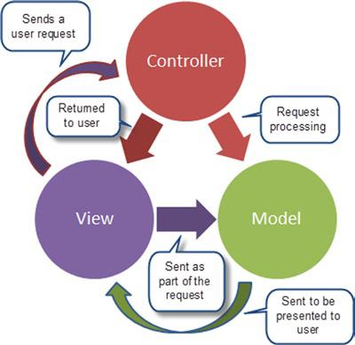

Figure 2 Model View Controller.

The design pattern used in this project will be MVC generally called model view controller. MVC allow business logic to be modified without impacting upon the rest of a system. In MVC it separate out application into the model which represent business logic, the view represent user output and controller represent input.

Below is a description of each aspect of MVC:

1. **Model**

A model is information used by a program. This might be a [database](https://techterms.com/definition/database), [file](https://techterms.com/definition/file), object, such as an [icon](https://techterms.com/definition/icon) or picture.

2. **View**

A view is the resources of showing instances inside an application. Examples contain showing a [window](https://techterms.com/definition/window) or switches or script inside a window. It contains anything that the user can see.

3. **Controller**

A controller updates both models and views. It receives [input](https://techterms.com/definition/input) and accomplishes the equivalent update. Let’s take example, a controller can inform a model by altering the attributes of a character. It might alter the opinion by showing the updated character.

## 3.3 – System Architecture

The system architecture tier that will be used for this project will be the 3-tier. A three-tier architecture is a client-server architecture in which the practical process logic, data access, computer data storage and user interface are established and upheld as independent elements on discrete stages. (milner, 2015)

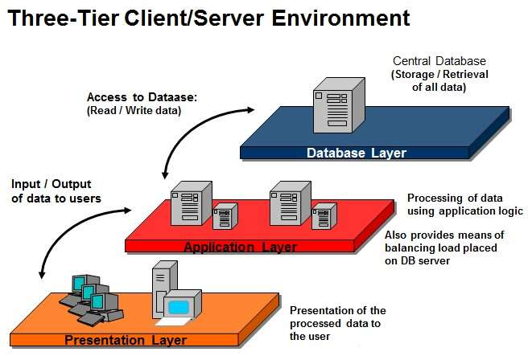

Figure 3 3-tier architecture model.

The three tiers in a three-tier architecture are:

**Presentation Tier**🡪

It conquer upper level data and shows facts related to services offered on a web. The main function of this tier is it attaches with other tiers by delivering results to the browser and other tiers in the network.

**Application Tier**🡪

Application tier is generally also called middle tier or logic tier where information is generally pulled from the presentational tier. It regulate application functionality by implementing complete processing.

**Database Tier**🡪

In data tier generally information or data is retrieved and store in a database server. Data in this tier is preserved independent of application servers or business logic.

# Chapter 4 –Scheduling

## 4.1 – WBS (Work Breakdown Structure)

A work-breakdown is a process of breakdown of a project into smaller components. A work breakdown arrangement is an important project that arranges the squad's work into controllable segments. (Thomas, 2019)

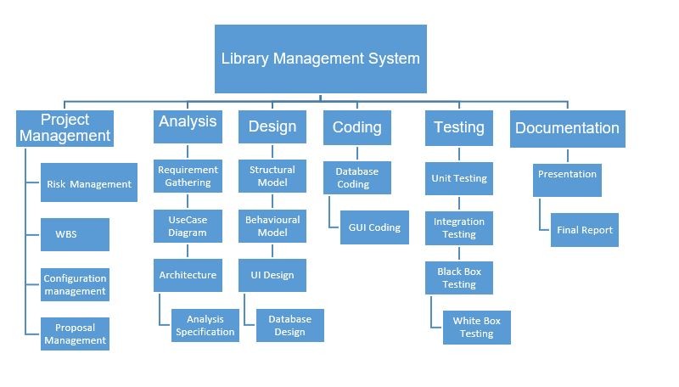

Figure 4 WBS diagram.

As we know, WBS is used to breakdown of a project into smaller component. So, in the above figure I breakdown my work into 6 different phases and again those phase is divided into other sub phases for being able to understand the project clearly.

## 4.2 – Milestones

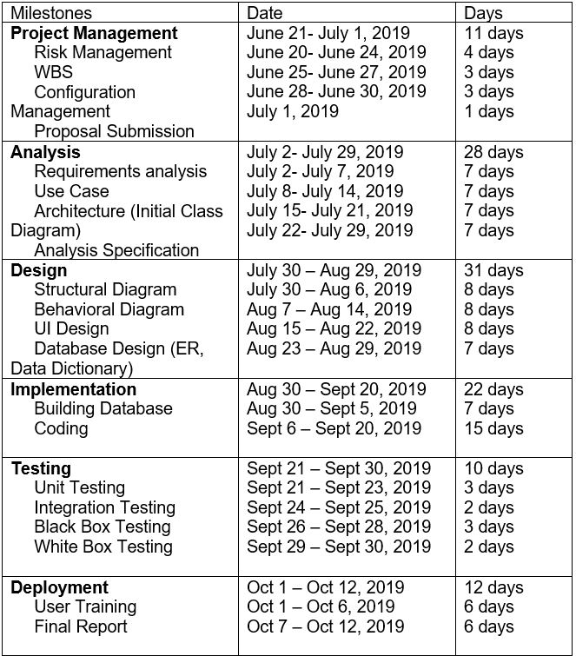

Table 1: Time Estimation of the Project.

So, in the given time estimation the project stages are assigned a time setting within project is expected to be completed. The main purpose of drawing this table is to deliver project on time and also helps in a better time management.

## List of Milestone

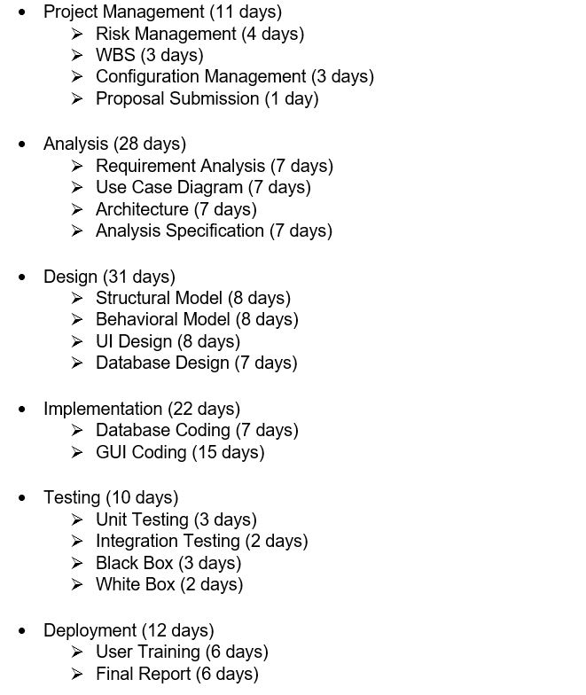

## Description of Milestone

* **Project Management (11 days)**

In this phases I estimate 11 days to complete the all requirement. Where risk management need 4 days to complete, WBS (work breakdown structure) needs 3 days, configuration management needs 3 days and for proposal submission I need 1 days to complete this project. This phase’s start date was June 21, 2019 to end date of July 1, 2019.

* **Analysis (28 days)**

In this phases I estimated 28 days to complete the all the given requirements, where requirement analysis needs 7 days to complete, Use Case Diagram needs 7 days, Architecture needs 7 days as well at last Analysis Specification also needs 7 days to complete. This phase start date will be from July 2, 2019 to end date of July 29, 2019.

* **Design (31 days)**

In this phases I estimated 31 days to complete the all the given requirements, where I give 8 days for structural model, 8 days for behavioral model again 8 days for UI Design and at last 7 days for Database Design. This phase start date will be from July 30, 2019 to end date of Aug 29, 2019.

* **Implementation (22 days)**

In this phase I estimated 22 days to complete the all given requirements, where I give 7 days for database coding and 15 days for GUI coding. This phase start date will be from Aug 30, 2019 to end date of Sept 20, 2019.

* **Testing (10 days)**

In this phase I estimated 10 days to complete the all given requirements, where I give 3 days for Unit Testing, 2 days for Integration Testing, and 3 days for Black box Testing and at last 2 days for White Box Testing. This phase start date will be from Sept 21, 2019 to end date of Sept 30, 2019.

* **Deployment (12 days)**

In this phase I estimated 12 days to complete all the given requirements, where I give 6 days for User Training and 6 days for Final Report. This phase start date will be from Oct 1, 2019 to end date of Oct 12, 2019.

## 4.3 – Gantt chart

Gantt chart is a kind of bar chart that demonstrate a project schedule. In Gantt chart it list the tasks to be executed on the vertical axis and time intervals on the horizontal axis. Gantt chart demonstrate the start and finish dates of the element of the project. This method maximizes the glide time available for all tasks. It is useful for planning and scheduling project and also helps to manage the dependencies of the tasks.

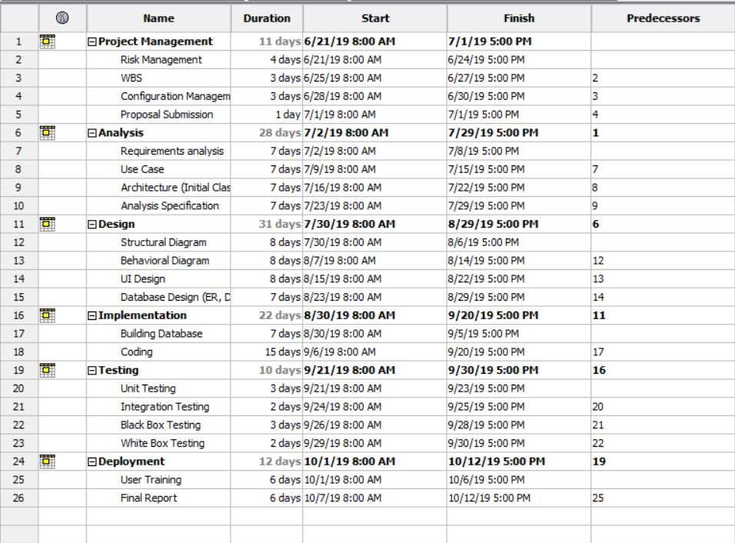

Figure 5 scheduling of the project.

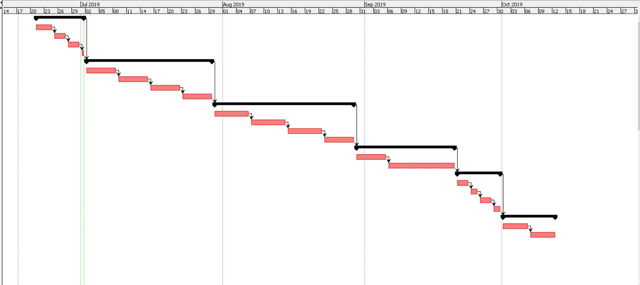

Figure 6 Gantt chart of Library Management System

# Chapter 5 –Risk Management

It is the procedure used by job managers to reduce any possible difficulties that may undesirably influence a project's schedule. Risk is any unpredicted occurrence that might distress the persons, procedures, technology, and resources involved in a project.

Risk management includes the following tasks:

* To recognize risks with their respective causes.
* Categorize and arrange the all possible risks.
* Monitor for risk causes during the project.
* Connect risk position throughout project. (Rouse, 2016)

Following are the risk and their management for their project.

**Impact = likelihood * Consequence**

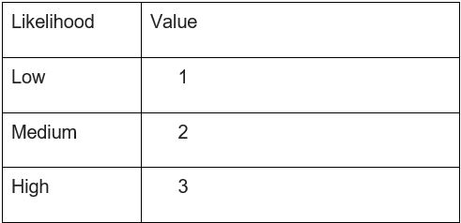

Table 2: likelihood.

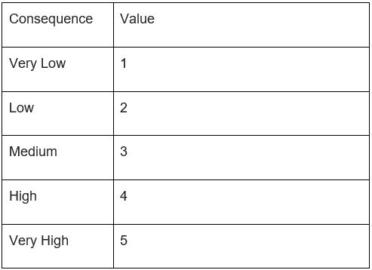

Table 3: Consequence.

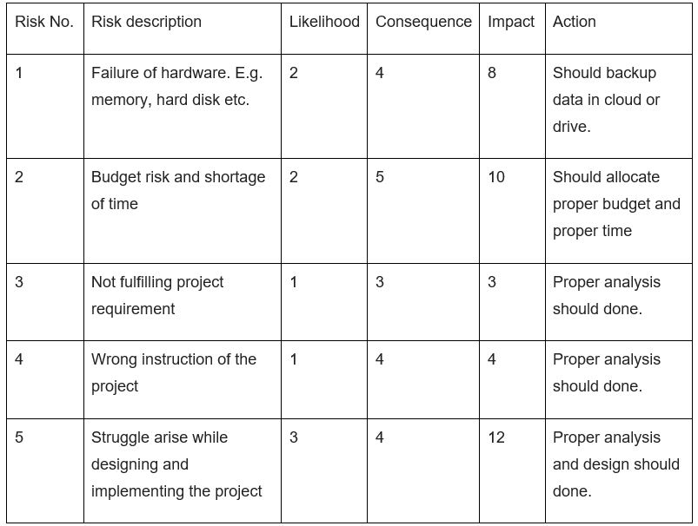

Table 4: Risk Management.

# Chapter 6 –Configuration Management

Configuration management is a system manufacturing procedure for starting and preserving reliability of a creation's act, practical, and bodily attributes with its requirements, design, and operative information during its lifecycle.

The following reason for using software configuration management

* Changes in requirement of the project.
* Needs to change the project schedule.
* Due to uncertain change of Government rules and regulation.
* It helps to reduce the redundancy of project.

6.1 -Version Control

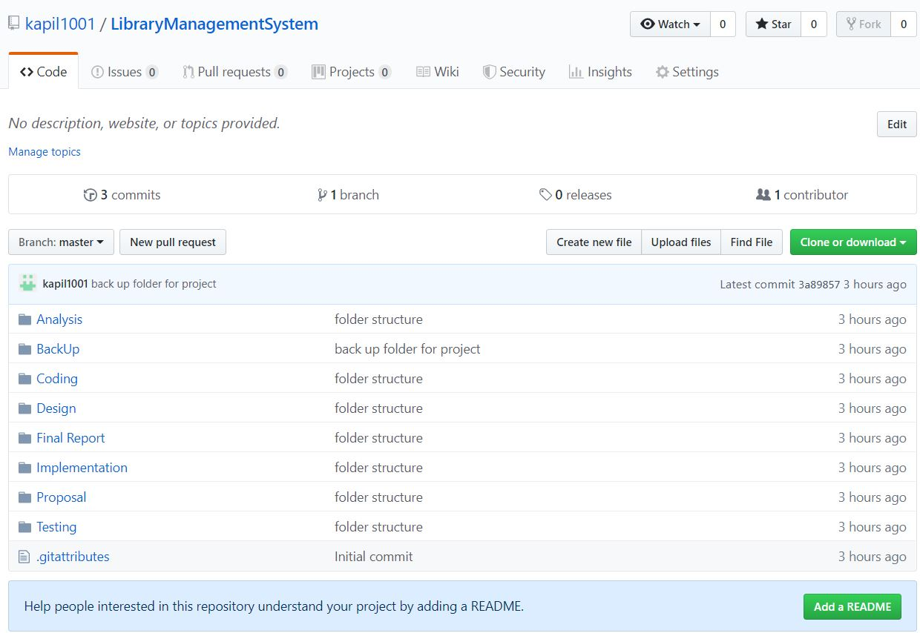

Figure 7 GitHub directory of Library Management System

For the safety of project I have created a backup folder where there are sub folders (Analysis, design, coding, testing etc.) for describing each stages of the project. As well as I have created GitHub account named kapil1001 for online backup where all folders are stored for future use. The main reason for using GitHub account is code that has been used previously can be reused here which helps to save time for project. Below is the link of GitHub Directory <https://github.com/kapil1001/LibraryManagementSystem>.

As well as, I have created backup in my local PC. Below is the project local backup directory.

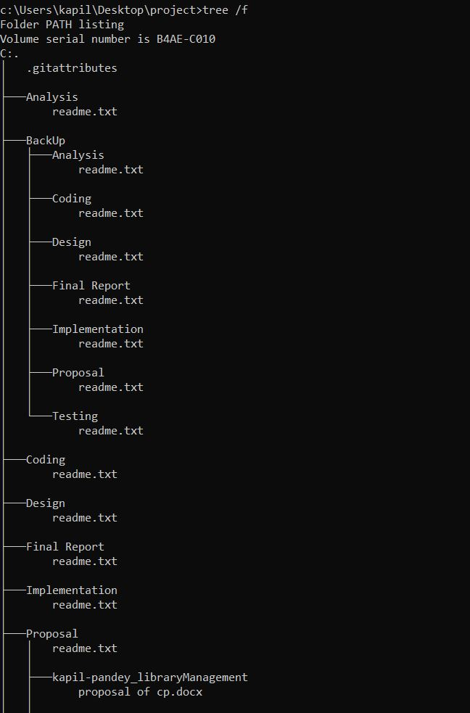

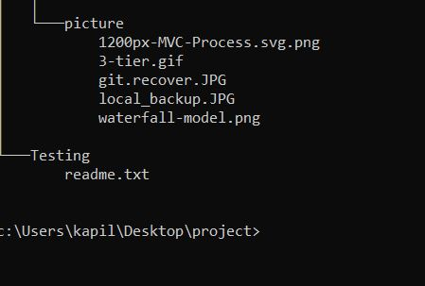

Figure 8 Project Local backup Directory.

## 6.2 -Release Management

It is the process of planning, managing and controlling a software form through different stages. So in this activity each release item has to permit through number of stages as well as it has to pass through a number of tests. Mainly, release management main motto is to ensure that all the checks and balance have been met to confirm the risk of code of failure in manufacture is reduced. It also checks or confirm the integrity of the live environment is secured and accurate element are released.

## 6.3 – Change Management

As we know changes can occur anytime in a project. Let’s take example during development of project we may run out of money and we need to change cost baseline which result our project doesn’t complete within specified time and may require a time postponement. So these type of changes involving the project baselines are managed through change management system. The main objective of change management system is to execute the accepted changes to the project with a least amount of disturbance. So in change management system if changes required, firstly it is investigated for any possible impact on any other project control and after that it either give decision of approved or rejected.

# Chapter 7 –Conclusion

Therefore, the main motto of having library management system is for automating the work in a library and also useful to insert, update, store information about books magazines into computerized way. So, with the help of WBS diagram the project is divided into many sub division and also able to show time allocated for sub-division work. Gantt chart is done for scheduling the work. As well as for proper development of project I have listed all possible risk with its solution.

# Chapter 8 -References

Coplien, J., 2009. *wikipedia.* [Online]   
Available at: https://en.wikipedia.org/wiki/Model%E2%80%93view%E2%80%93controller  
[Accessed 27 06 2019].

milner, j., 2015. *jinfonet.* [Online]   
Available at: https://www.jinfonet.com/resources/bi-defined/3-tier-architecture-complete-overview/  
[Accessed 29 06 2019].

Rouse, M., 2016. *SearchCompliance.* [Online]   
Available at: https://searchcompliance.techtarget.com/definition/risk-management  
[Accessed 27 06 2019].

Thomas, G., 2019. *wikipedia.* [Online]   
Available at: https://en.wikipedia.org/wiki/Work_breakdown_structure  
[Accessed 27 06 2019].

Weisert, C., 2019. *wikipedia.* [Online]   
Available at: https://en.wikipedia.org/wiki/Waterfall_model  
[Accessed 27 06 2019].